Management sale SW

Software Development Plan (Small Project)

Version <1.0>

Revision History

|  |  |  |  |
| --- | --- | --- | --- |
| **Date** | **Version** | **Description** | **Author** |
| 08/11/2019 | 1.0 | WBS, Gantt chart, project resourcing, risk management | Nguyễn Tuấn Phùng |
| 08/11/2019 | 1.1 | Write introduction and project overview (project purpose, scope, objectives, assumptions and constraints, project deliverables) | Võ Khánh Vy |
| 08/11/2019 | 1.2 | Write Project Organization(Organizational Structure, Roles and Responsibilities),  Phase Plan | Hồ Bùi Văn Quang |
|  |  |  |  |

Table of Contents

1. Introduction 4

1.1 Purpose 4

1.2 Scope 4

1.3 Overview 4

2. Project Overview 4

2.1 Project Purpose, Scope, and Objectives 4

2.2 Assumptions and Constraints 5

2.3 Project Deliverables 5

3. Project Organization 5

3.1 Organizational Structure 5

3.2 Roles and Responsibilities 6

4. Management Process 6

4.1 Project Estimates 6

4.2 Project Plan 6

4.2.1 Phase Plan 7

4.2.2 Iteration Objectives 8

4.2.3 Releases 8

4.2.4 Project Schedule 8

4.2.5 Project Resourcing 8

4.3 Project Monitoring and Control 8

4.3.1 Requirements Management 8

4.3.2 Reporting and Measurement 8

4.3.3 Risk Management 8

4.3.4 Configuration Management 9

Software Development Plan (Small Project)

# 

# Introduction

## Purpose

This software development plan was created for the purpose of collecting the full range of information necessary for project development. It describes the group's approach to software development and it is used as a tool for project management.

The following people use the *Software Development Plan*:

* The project manager uses the plan to schedule the development process, allot the work to the members, check the progressing, make sure everything ok and complete the process project on time.
* Team members use it to keep track of the work you need to do, the start and end time of the job.

## Scope

This *Software Development Plan* describes the overall plan to be used by the <project name> project, including deployment of the product. The details of the individual iterations will be described in the Iteration Plans.  
The plans as outlined in this document are based upon the product requirements as defined in the *Vision Document*.

## Overview

This *Software Development Plan* contains the following information:

* Project Overview: provides a description of the project's purpose, scope, and objectives.  It also defines the deliverables that the project is expected to deliver.
* Project Organization: describes the organizational structure of the project team.
* Project management process: described using the project management process model above.

# Project Overview

## Project Purpose, Scope, and Objectives

Software management of the convenience store with a mission to bring convenience to consumers. With a rich and diversified list of goods, customers are free to choose products that are suitable for their needs.

* Purpose: To build a system to manage the operation of a convenience store (employee management, cargo management, import and export of goods, collection of expenses),..
* Scope: Software users including staff and management of the store
* Objectives: The software will meet the staff's business requirements and be able to do the shop management. Log in, log out, Change password, Insert the bill information to the system, Add member for new guest if they want to register, Read the member customer information, Read the bill information, import product from agency, manage staff .

## Assumptions and Constraints

Almost any project will have certain limitations and should be determined from the start of the project. To a minimum, assumptions and limitations should be clearly defined for the following factors:

* Schedule: The time to execute the project starts at the beginning of the course and ends at the end of the course.
* Resources: This project will be implemented by a group of 5 members including 1 project manager, developer, Tester and BA.
* Resources to use include lecture lectures of theoretical teachers, practical teacher documents provided, and reference many documents from the INTERNET.

## Project Deliverables

Here is a list of some deliverables:

|  |  |  |
| --- | --- | --- |
| Phase | Deliverables | Date |
| Analysis | Analysis Document | 03/11/2019 |
| Project Planning | Software Development Plan | 08/11/2019 |
| Design | Database Design Document, Design review | Update |
| Development | Data dictionary | Update |
| Integration | Integration plan and results | Update |
| Testing | Test plan, Test results | Update |
| Operation | Code, App, Final Presentation | Update |

# Project Organization

## Organizational Structure

The project team:

## Roles and Responsibilities

|  |  |
| --- | --- |
| **Person** | **Role** |
| Thanh Long, Project Manager | Responsible for maintain the Project store management, keep the project team focused on the right goal. |
| Nhật Phương, Designer | The designer creates the interface of the software, and defines the operations, attributes and relationships of entities or classes. |
| Tuấn Phùng, Architect | Identify the overall structure for the project, provide design sketches and details, prepare budget. |
| Khánh Vy, Business Analyst | Working directly with customers, get the requirements from them and transfer to team; analyses the effect of changings to the process. |
| Văn Quang, Tester | Responsible for executing testing, detect the bug, evaluation and recovery system from errors. |

# Management Process

## Project Estimates

The Inception phase of project will take 2 weeks.  
The Elaboration phase of project will take 1 weeks.  
The Construction phase of project will take 3 weeks.

The Transition phase of project will take 2 weeks.

## Project Plan

None

### Phase Plan

WBS model:

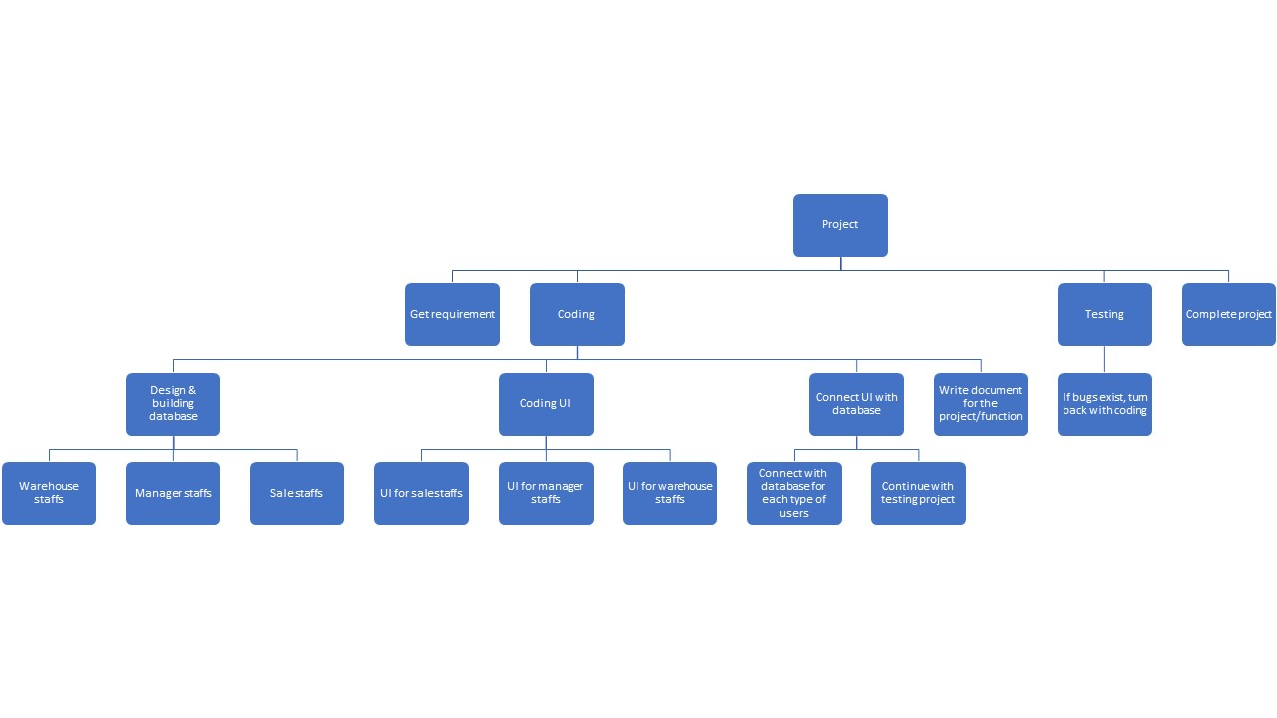

Gantt chart:

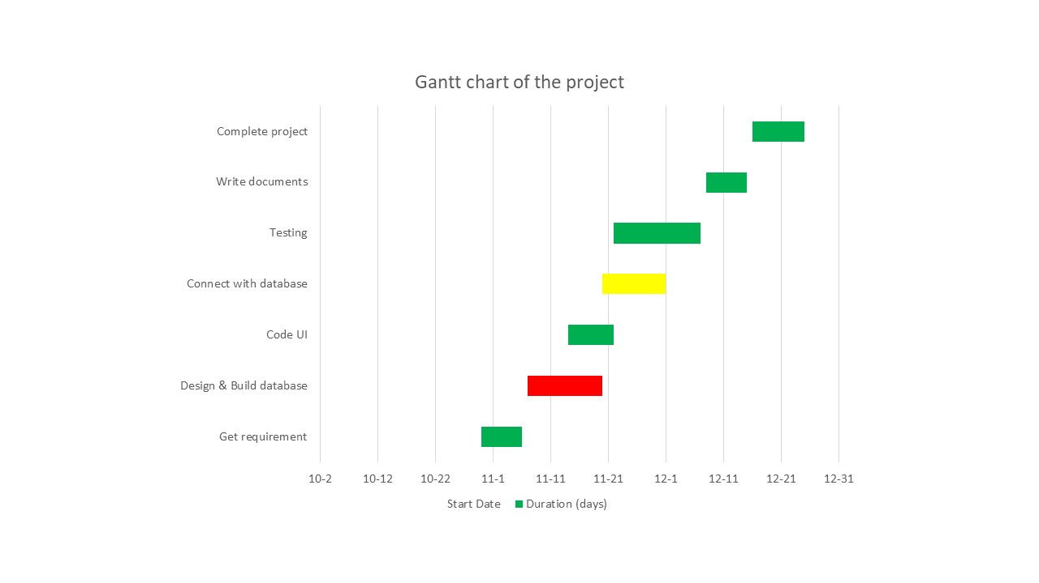

### Iteration Objectives

### Releases

### Project Schedule

### Project Resourcing

|  |  |  |
| --- | --- | --- |
| No. | Team’s members name | Roles |
| 1 | Lý Thanh Long | Project manager, provide task for team’s members |
| 2 | Nguyễn Lý Nhật Phương | Design database, build database |
| 3 | Nguyễn Tuấn Phùng | Design database, build database and UI |
| 4 | Hồ Bùi Văn Quang | Code UI, connect with database |
| 5 | Võ Khánh Vy | Code UI, connect with database, secretary for team |

* Special skills that each member have to train for the project:
  + .NET
  + MSSQL
  + Solving transaction/deadlock when occur

## Project Monitoring and Control

### Requirements Management

The requirements for this system are captured in the Vision document. Requested changes to requirements are captured in Change Requests, and are approved as part of the Configuration Management process.

### Reporting and Measurement

Updated cost and schedule estimates, and metrics summary reports, will be generated at the end of each iteration.

The Minimal Set of Metrics, as described in the RUP Guidelines: Metrics, will be gathered on a weekly basis. These include:

Earned value for completed tasks. This is used to re-estimate the schedule and budget for the remainder of the project, and/or to identify need for scope changes.

Total defects open and closed – shown as a trend graph. This is used to help estimate the effort remaining to correct defects.

Acceptance test cases passing – shown as a trend graph. This is used to demonstrate progress to stakeholders.

In addition, overall costs will be monitored against the project budget.

### Risk Management

Risks will be identified in Inception Phase using the steps identified in the RUP for Small Projects activity “Identify and Assess Risks”. Project risk is evaluated at least once per iteration and documented in this table. The risks of the greatest magnitude are listed first in the table.

|  |  |  |
| --- | --- | --- |
| **Risk Ranking (High, Medium, Low)** | **Risk Description and Impact** | **Mitigation Strategy and/or Contingency Plan** |
| Medium | Deadlock while insert data | Build the stored procedure/ function prevent deadlock |
| Medium | Dirty read when read data | Build the stored procedure/ function prevent dirty read |
| High | Wrong query | Carefully build the database |
| Low | Poor performance | Try to make better |

### Configuration Management

Appropriate tools will be selected which provide a database of Change Requests and a controlled versioned repository of project artifacts.

All source code, test scripts, and data files are included in baselines. Documentation related to the source code is also included in the baseline, such as design documentation. All customer deliverable artifacts are included in the final baseline of the iteration, including executables.